How to link interface & the DB so that the table gets populated via a submit button
Step 1: Create Button – Change Button Behaviour
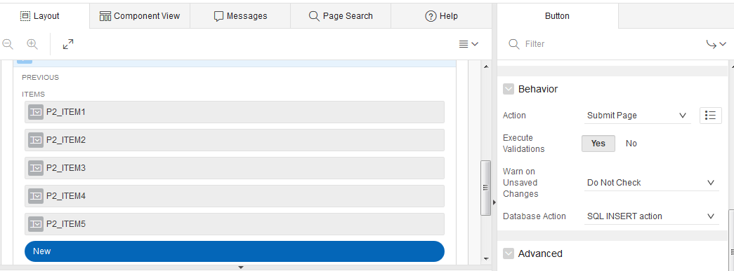
Step 2: Create a rule In Events on click of the button
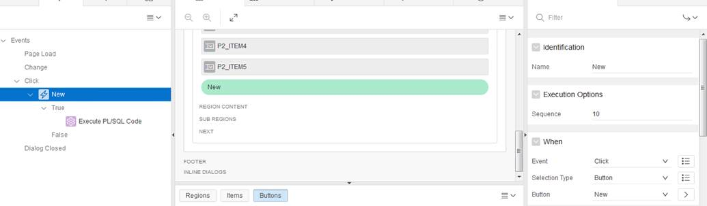

If true execute code.
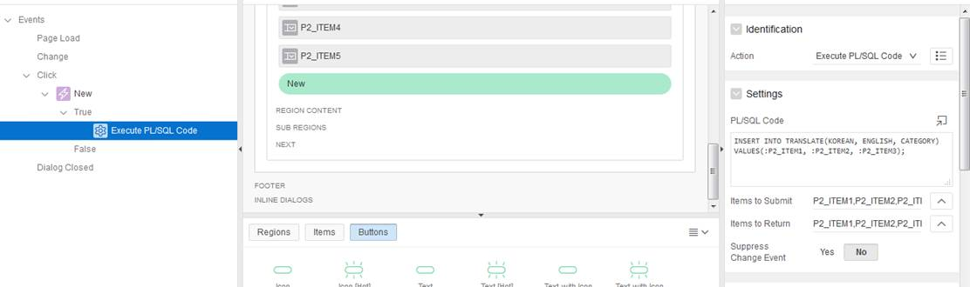
SQL CODE
INSERT INTO TRANSLATE(KOREAN, ENGLISH, CATEGORY) # Pick categories to insert
VALUES(:P2_ITEM1, :P2_ITEM2, :P2_ITEM3); # Pick values to insert based on the item name

