Before You Begin

What Do You Need?
- Oracle Application Express workspace
- Spreadsheet to create the database application - The tasks.txt spreadsheet is used in this tutorial.

Creating an Application from Spreadsheet Data
1. On the Workspace home page, click the App Builder icon.
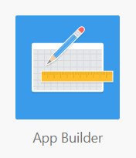

- Click the Create button.
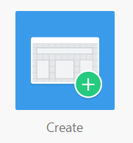

- In the Create an Application modal window, select From a spreadsheet.

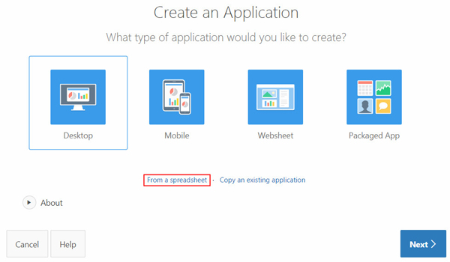

- For Load Method, select Upload file, comma separated (*.csv) or tab delimited and click Next.

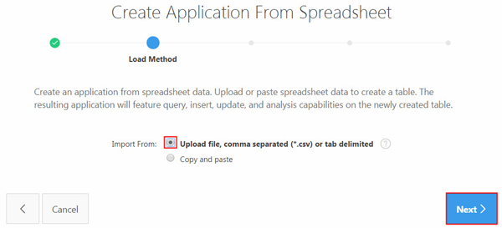

- For Data, click Choose File, navigate to the spreadsheet (or CSV) file, and click Open. Enter \t for Separator, ensure that "First row contains column names." checkbox is enabled, and click Next.

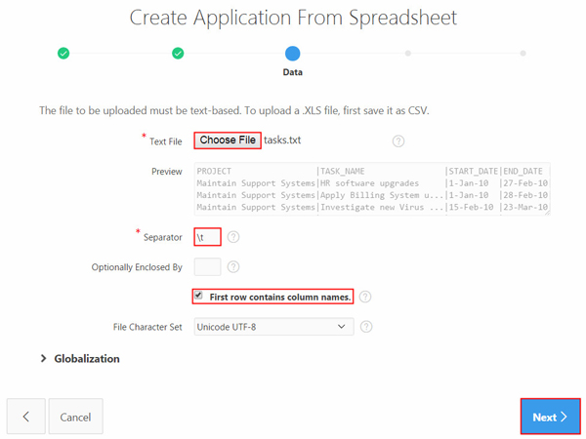

- For Table Properties, select HR for Schema and enter TASKS for Table Name. Review the table properties and click Next.

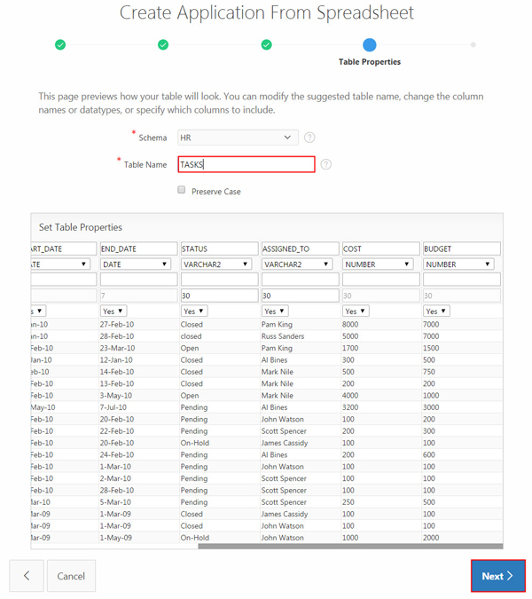

- For Application Options, accept the default for Application Name and Report Type and click Create Application.

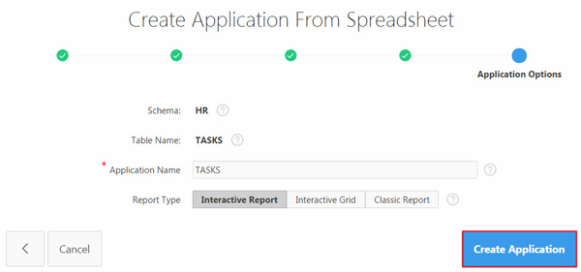

- The application is created successfully.

Executing and Reviewing the Application
- On the Application home page, click the Run Application icon.
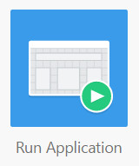

- Enter your login credentials and click Log In.
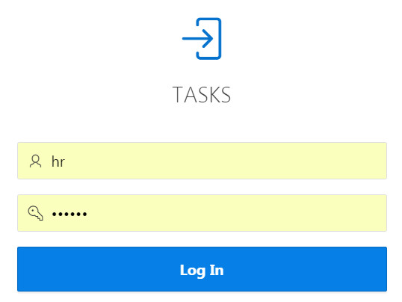

- The home page of the TASKS application, containing the interactive report, is displayed. Click the Edit icon in the first row.

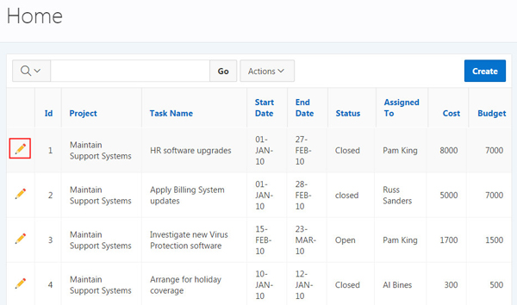

- The modal window to edit the Tasks entry appears. Change the value for Cost and click Apply Changes.
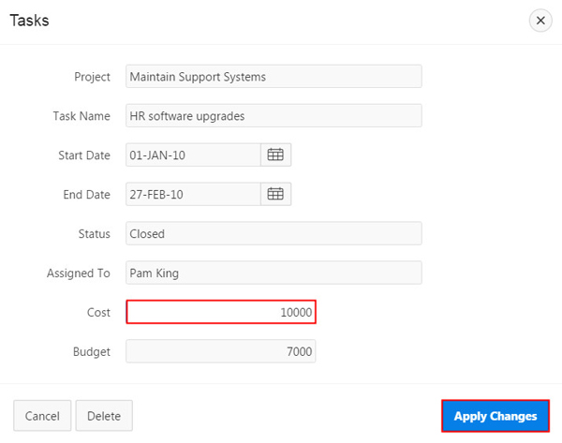

- The Cost has been updated. Now you create a new Task. Click Create.
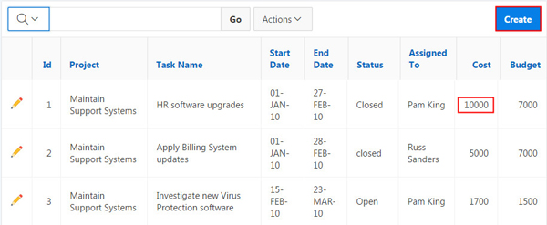

- Enter details for the new task and click Create.
The new task is successfully created. You will be able to see the new task in the Interactive Report.

