Step 1: Upload an Image to Shared Components – Static Application Files then copy reference.
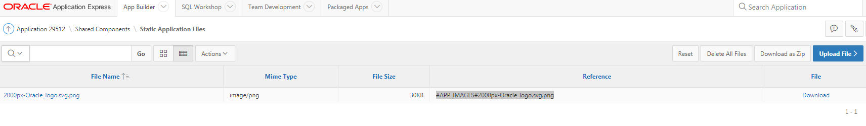

Step 2: In the target page within the application place an image file within the content body.

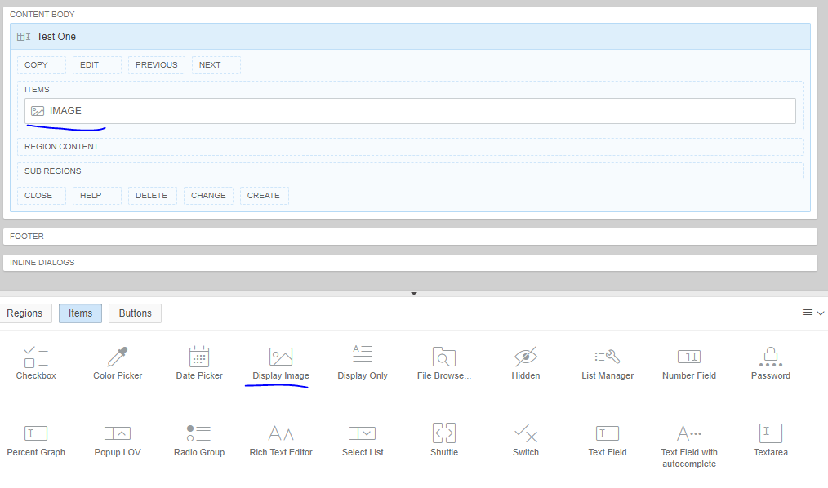

Step 3: Click on the image and in the right hand menu select:

From Settings: Image URL stored in Page Item Value:
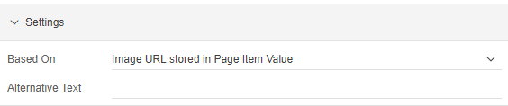

From Source: Paste Reference from Step 1
