Step 1: Inside App click Shared Components.

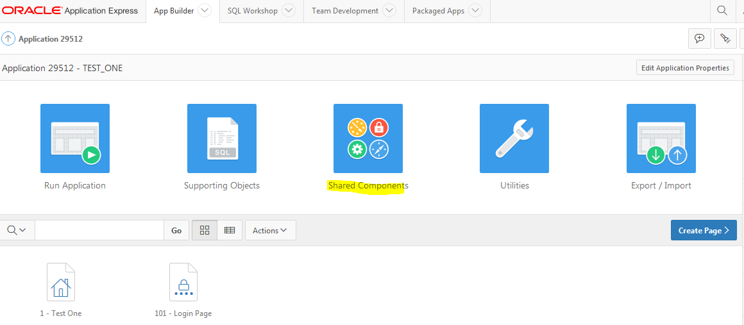

Step 2: Authentication Schemes.

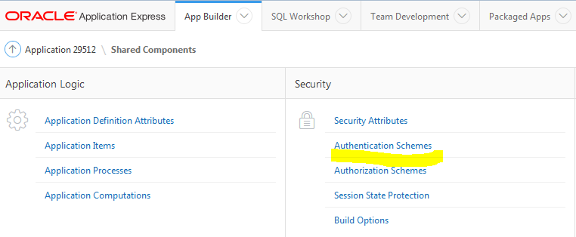
Step 3: Create
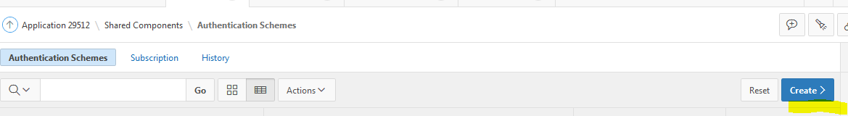

Step 4: Based on a Pre-existing Scheme and Click Next.
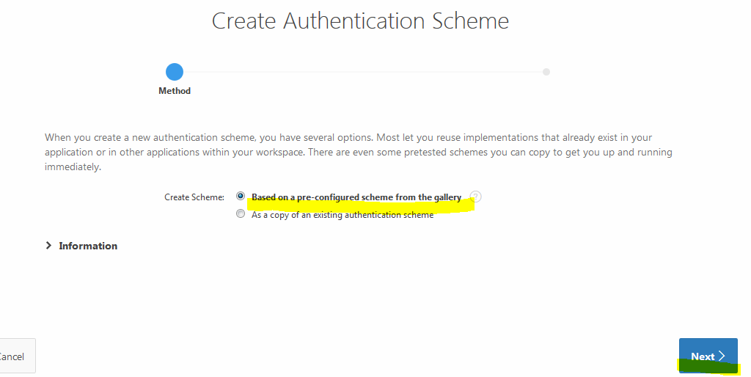

Step 5: Enter a name choose SSO as Scheme Type and Click Create Authentication Scheme.

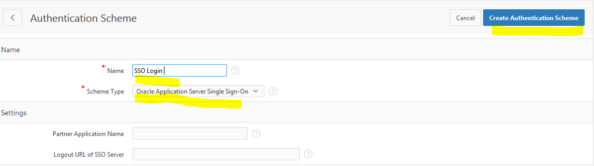
Step 6: Make sure the new scheme is current (this should happen automatically).
